Dynamic Destination Mapping

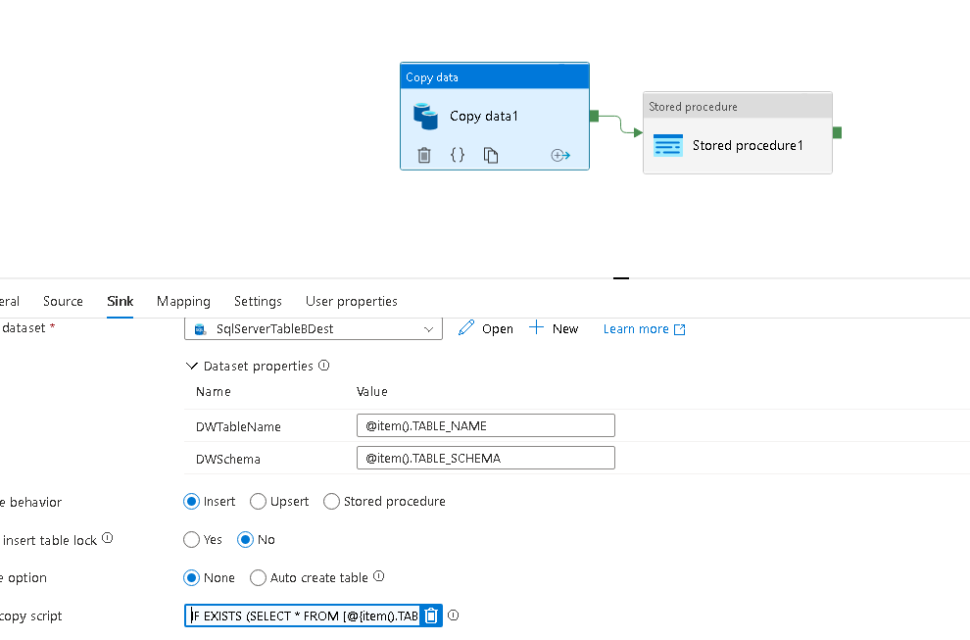

IF EXISTS (SELECT * FROM [@{**item**().**TABLE_SCHEMA**}].[@{**item**().**TABLE_NAME**}])TRUNCATE TABLE [@{**item**().**TABLE_SCHEMA**}].[@{**item**().**TABLE_NAME**}]